|  |  |
| --- | --- |
| **S.No** | **Description of the Project** |
| 1 | INTRODUCTION  1.1 Overview  1.2 Purpose |
| 2 | Problem Definition & Design Thinking  2.1 Empathy Map  2.2 Ideation & Brainstorming Map |
| 3. | RESULT |
| 4. | ADVANTAGES & DISADVANTAGES |
| 5. | APPLICATIONS |
| 6. | CONCLUSION |
| 7. | FUTURE SCOPE |

|  |
| --- |
| INTRODUCTION |

* 1. **Overview:**

Estimation of business expenses is the process of forecasting and calculating the anticipated costs and expenditures that a business is likely to incur over a specific period, typically for budgeting and financial planning purposes. This estimation is a critical aspect of managing a company's finances effectively. Here are some key points to consider when estimating business expenses.

Estimating business expenses is an important step in determining how much money you need to start and keep your business running without encountering cash flow problems. Every business has different requirements, depending on the type of products or services it sells, the size of the company, and the stage of growth of the business. Even so, most business expenses are either one-time costs or ongoing expenses required to keep operations going.

* 1. **Purpose**
* Budgeting: Estimating expenses helps businesses create a budget, which is a financial plan that outlines expected revenues and expenditures for a specific period (usually a fiscal year). A well-prepared budget allows a business to allocate resources effectively and plan for its financial needs.
* Financial Planning: Business expense estimation is a crucial part of financial planning. It helps businesses anticipate future financial obligations, allowing them to make informed decisions about investments, expansion, and debt management.
* Pricing Strategy: Understanding your expenses is essential for setting prices for products or services. Accurate expense estimates help determine the minimum price necessary to cover costs and generate a profit.
* Profitability Analysis: Estimating expenses helps businesses assess their profitability. By comparing estimated expenses to actual expenses and revenues, businesses can gauge their financial performance and make necessary adjustments to improve profitability**.**
* Investment Decisions: When seeking investors or loans, businesses need to demonstrate a clear understanding of their expected expenses. Investors and lenders often review expense estimates to evaluate the financial health and sustainability of the business.

|  |
| --- |
| **Problem Definition and design thinking** |

2.1 Empathy Map:

The Empathy Map describe about the categories available in Estimation of Business Expenses. Gives you the knowledge about the overall execution of Business.

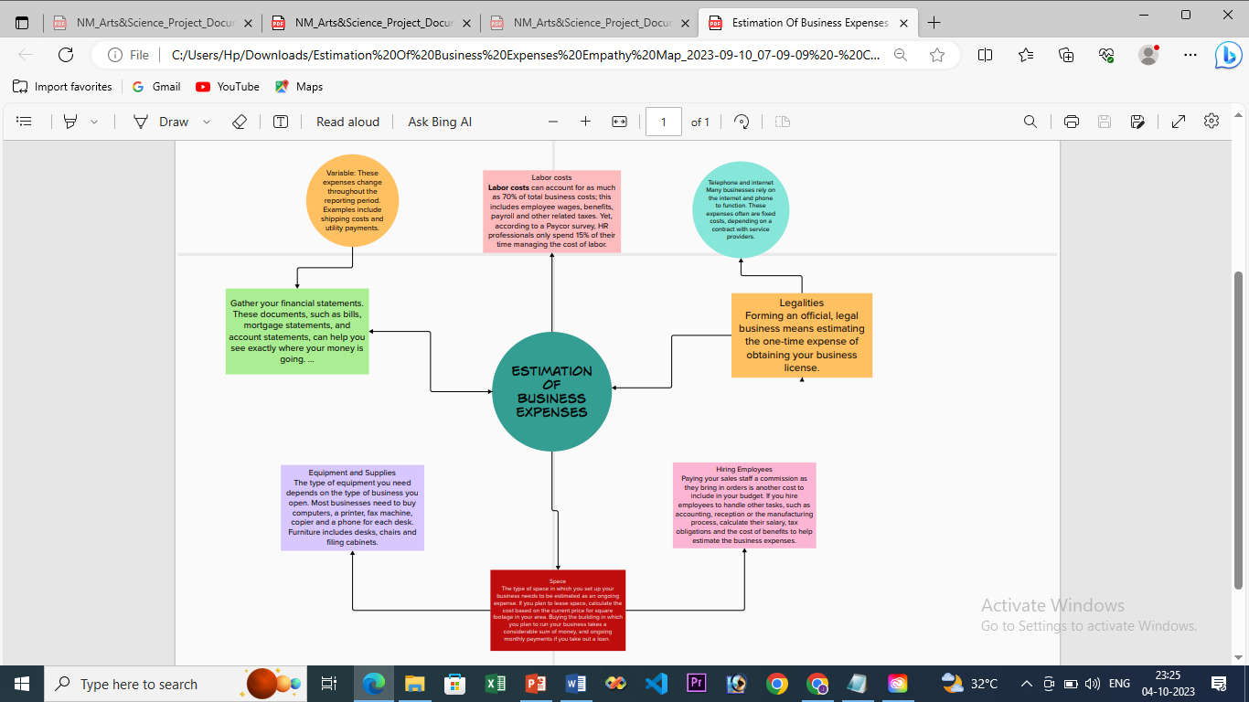

2.2 Ideation & Brainstorming Map:

The Brainstorming Map shows the team members Point of view of Estimation towards Business expenses.

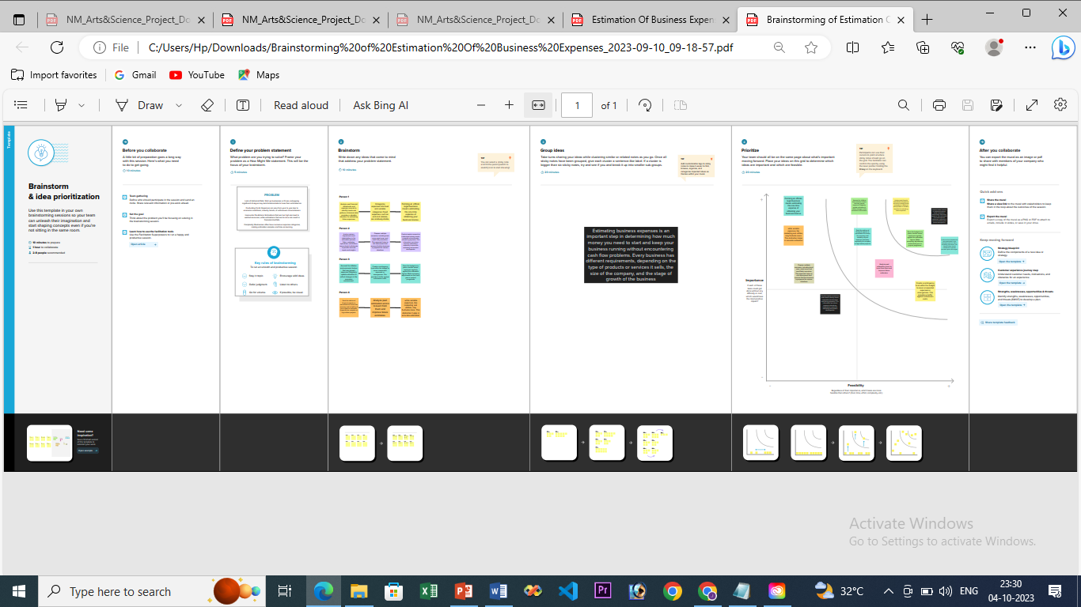

|  |
| --- |
| **RESULT** |

The result of estimating business expenses is a budget or financial plan that outlines your expected expenditures over a specific period, typically a fiscal year or a business quarter. This budget serves as a roadmap for managing your company's finances and helps you make informed decisions about resource allocation, pricing, and profitability. Here are some key outcomes and benefits of estimating business expenses

|  |
| --- |
| **ADVANTAGES** |

* Budgeting: Expense estimation helps in creating a detailed budget, allowing businesses to plan and allocate resources effectively. This ensures that there are enough funds available to cover necessary expenses, preventing financial shortfalls.
* Financial Planning: Accurate expense estimates are essential for long-term financial planning and forecasting. They enable businesses to set realistic financial goals and make informed decisions about investments and growth strategies.
* Cost Control: By estimating expenses, businesses can identify areas where costs can be reduced or optimized. This proactive approach to cost control can lead to increased profitability and sustainability.
* Stakeholder Communication: Investors, shareholders, and lenders often require accurate expense estimates to make informed decisions about their involvement with a business. Reliable estimates can instill confidence in stakeholders.

|  |
| --- |
| **DISADVANTAGES** |

* Inaccuracy: Expense estimates are not always precise, and actual expenses can vary significantly from estimates. This can lead to budgetary shortfalls or surpluses, making it challenging to manage finances effectively.
* Unforeseen Expenses: Some expenses may be challenging to predict or may arise unexpectedly. Estimations may not account for these unforeseen costs, potentially leading to financial strain.
* Overestimation: In an attempt to be cautious, businesses may overestimate expenses, which can result in unnecessary financial constraints and reduced profitability.
* Underestimation: Conversely, underestimating expenses can lead to financial difficulties, as businesses may not have sufficient funds to cover their obligations when actual expenses exceed estimates.

|  |
| --- |
| **APPLICATIONS** |

* Budgeting
* Pricing Strategy
* Financial Planning
* Strategic Planning
* Risk Management

|  |
| --- |
| **CONCLUSION** |

In conclusion, estimating business expenses is a fundamental aspect of financial planning and management. It enables a business to make informed decisions, allocate resources efficiently, and maintain financial stability. Regular review and flexibility in the budgeting process are essential to ensuring that the estimates remain accurate and relevant in a dynamic business environment.

|  |
| --- |
| **FUTURE SCOPE** |

* Advanced Data Analytics: Businesses will increasingly use advanced data analytics and machine learning algorithms to predict and estimate expenses more accurately. This could involve analyzing historical data, market trends, and external factors to make more informed cost projections.
* Real-time Expense Tracking: Real-time expense tracking tools and software will become more prevalent. These tools can provide instant insights into spending patterns, helping businesses make quicker decisions and adjust their budgets in real-time.
* Automation and AI: Automation and artificial intelligence will play a significant role in expense estimation. AI-powered chatbots, virtual assistants, and software will handle routine expense calculations and approvals, reducing human error and saving time.
* Mobile Expense Estimation: Mobile apps and platforms will continue to play a crucial role in expense estimation. Employees will be able to capture expenses on the go, and these expenses will seamlessly integrate with the company's financial systems.
* Globalization Challenges: Businesses operating on a global scale will face unique challenges in estimating expenses due to currency fluctuations, international tax laws, and cultural differences. Specialized tools and experts in international finance will be in demand.
* Cybersecurity Costs: With the increasing threat of cyberattacks, businesses will need to allocate resources to cybersecurity. Estimating and budgeting for cybersecurity expenses will be crucial to protecting sensitive data and operations

Dashboard Link:

<https://public.tableau.com/views/BusinessExpenditure_16964437650510/BusinessExpenditure?:language=en-US&:display_count=n&:origin=viz_share_link>

Story link:

<https://public.tableau.com/views/BusinessExpenses_16964401967670/Expenses?:language=en-US&:display_count=n&:origin=viz_share_link>

Video Demonstration Link:

[https://drive.google.com/file/d/13ZJQgx7- LoUBkBTb7OFlqaJ43IofkIFs/view?usp=drivesdk](https://drive.google.com/file/d/13ZJQgx7-%20%20%20LoUBkBTb7OFlqaJ43IofkIFs/view?usp=drivesdk)

*\*Thank you\**